DWR “Delta Conveyance Project”
Scoping Comments – Proposed Alternative
____

“YOLO BYPASS/FREMONT WEIR PROPOSAL”

A UNIQUE WATER CONVEYANCE ALTERNATIVE
(April 17, 2020)
____

Submitted By: David Abelson, Environmental Law Attorney
Emailed To: California Department of Water Resources
DeltaConveyanceScoping@water.ca.gov

cc via Email To: Wade Crowfoot, Secretary, Natural Resources Agency
mailto:secretary@resources.ca.gov Wade.Crowfoot@resources.ca.gov

cc via Email To: Karla Nemeth, Director, Ca. Dept. of Water Resources
Karla.Nemeth@water.ca.gov

Contact Information:
David Abelson, Sacramento
abelsonfamily@comcast.net
(916) 446 – 6178
April 17, 2020

Topic: Delta Conveyance Project/Scoping Comments
Submitted By: David Abelson, Environmental Law Attorney
Submitted via Email To: DWR (Dept. of Water Resources)
DeltaConveyanceScoping@water.ca.gov

Email cc : Karla Nemeth, Director, Ca. Dept. of Water Resources
Email cc: Wade Crowfoot, Secretary, Natural Resources Agency

Re: DCP Scoping Comments – West-Side Alternative

These comments are submitted pursuant to the Notice of Preparation (NOP) of an Environmental Impact Report (EIR) for the Delta Conveyance Project (DCP), issued by the California Department of Water Resources (DWR) on January 15, 2020, as modified by the March 17th “Update” extending the comment period to April 17, 2020.

I. The CEQA Scoping Process and Alternatives Mandate

The California Environmental Quality Act (CEQA) requires project proponents to consider “a reasonable range of potentially feasible alternatives that will foster informed decision making and public participation.” In the “Alternatives” section of its NOP, DWR states that “the scoping process [for the DCP] will inform the preliminary locations, corridors, capacities and operations of new conveyance facilities to be evaluated in the EIR.” The department also says that it will “make its final choice of potentially feasible alternatives to include in the Draft EIR after receipt of scoping comments.” (See NOP at p. 9)

In accordance with these statements, and the legal requirements pertaining to alternatives, it is imperative that DWR include in its Draft EIR an assessment of potentially feasible “west-side” or “western route” locations and corridors, specifically the “Fremont Weir/Yolo Bypass Alternative,” described herein.

II. Current Delta Conveyance Problems and DWR’s Proposed “East-Side” Solution

A. Current Delta Conveyance Problems

The primary goal of the proposed DCP is to ensure that a reliable supply of high-quality fresh water is available for export to existing end-user south of the Sacramento/San Joaquin Delta (delta). These exports provide water needed for irrigated agriculture, drinking water for millions of Californians, and numerous other beneficial uses.

To achieve this goal, the DCP seeks to address a number of serious problems caused by the existing “through-delta” water conveyance system. Two of the most pressing problems are: (1) water supply risks associated with mandated south-delta pumping restrictions that are required by law to protect threatened or endangered species (e.g. delta smelt and pacific salmon); and (2) water quality risks associated with potential salinity intrusion caused by weak levees, rising sea levels and/or regional earthquakes.

B. The Proposed “East-Side” Solution

Like numerous other proposals before it, the DCP seeks to address the twin concerns about water quality and water quantity by constructing an isolated conveyance system that skirts through or around the east-side of the Delta and then connects to the export facilities located near Tracy. As currently proposed the DCP would consist of up to three water diversion intakes and a single large conveyance tunnel sized to transport up to 7,000 cfs of water.

The proposed intakes and entrance to the tunnel would be located on the Sacramento River, up-stream from the central delta, near the north delta town of Hood. The tunnel would extend for approximately 40 miles to the south, conveying water beneath farmlands and small communities lying east of the delta. The tunnel would terminate at the existing water export facilities located near the south delta city of Tracy.

By removing and isolating the water transport system from the delta itself, the east-side project seeks to obtain a more reliable quantity of water for export. To achieve this goal, the proposed relocation may reduce some of the on-going damage to endangered fish specifies now caused by the existing pumps that are withdrawing large amounts of water directly from the south delta.

In addition, by removing the water transfer system from the delta itself, the DCP seeks to reduce the risks to water quality now posed by a combination of weak levees, rising sea levels and a large regional earthquake. Constructing an isolated conveyance tunnel deep underground may be one way to address such water quality concerns, but it is certainly not the only way.

III. Building A Better Mousetrap: The West-Side/Yolo Causeway Alternative

A. Introduction

Question: What should DWR do if it receives thoughtful scoping comments that identify one or more “potentially feasible” west-side alternatives to the proposed tunnel project, particularly if such alternatives could (1) achieve the twin goals of better water quality and more reliable water quantity; (2) provide far greater environmental benefits; and (3) cause far fewer adverse environmental and social impacts?

Answer: To comply with CEQA’s scoping and alternatives requirements, DWR should place such potentially feasible west-side alternatives into its draft EIR, thereby providing a meaningful opportunity for the thorough and thoughtful review needed to “foster informed decision making and public participation.”

B. The Proposed West-Side “Fremont Weir/Yolo Bypass” Alternative

These scoping comments request that DWR broaden the scope of its EIR to include a west-side “Fremont Weir/Yolo Bypass Alternative,” as presented in further detail below.

1. Initial Assumptions and Goals

Before describing the west-side Fremont Weir/Yolo Bypass (FW/YB) alternative, it is important to emphasize that this proposal is not intended to answer the imponderably complex question of “how much fresh water can or should be diverted from one watershed to another?”

Rather, this west-side alternative accepts the fact that some amount of water has been and will continue to be transferred from the Sacramento River watershed to regions south of delta. Thus, the relevant question becomes “how can such water transfers be accomplished in the most natural and least destructive way possible?”

2. Proposing Yet Another Highly-Engineered Concrete Channel Is Not The Right Answer

It’s been well over half a century since voters first approved the sale of bonds to build the State Water Project (1960). For the past six decades, water planners and engineers have proposed to build various types of physical structures designed to move fresh water from the Sacramento River in the north, through and/or around the Delta, and on to various destinations south of there.

These physical structures have gone by many different names, including the “Delta Transfer Facility,” the “Peripheral Canal,” the “Cal/Fed Project,” the “Bay Conservation and Development Project (BDCP),” the “Water Fix,” the “Twin Tunnels,” and now the “Delta Conveyance Project (DCP).”

What all of these proposals have in common is one important characteristic -- they each rely primarily on brick and mortar structures designed and engineered to mechanistically isolate, divert and then transfer Sacramento River water from its natural channels to other locations outside of the watershed.

It has been said that the very definition of “insanity” is doing the same thing over and over again, and expecting a different result. So what does DWR have to lose by seriously considering a very different kind of approach to the problem? Absolutely nothing! So please read on with an open mind.

C. The Yolo Bypass -- An Outstanding Alternative Hiding In Plain Site

The west-side Fremont Weir/Yolo Bypass alternative asks everyone to step back from the mechanical engineering approach to solving the delta protection/water export conundrum. Remember, regardless of its various names, these mechanical engineering approaches have produced absolutely no positive results for more than half a century.

Instead, try to envision what might happen if a natural river system were allowed to accomplish most of work needed to provide (1) a reliable quantity and quality of fresh water for export; (2) a return of the lower Sacramento Valley watershed to its more natural state; and (3) substantial mitigation for any significant adverse impacts that remain.

1. Description of the West-Side Project’s Key Features

To achieve the water quality and quantity goals listed above, the west-side alternative would allow fresh water to flow naturally into and downstream through the Yolo Bypass, commencing at the Fremont Weir (near Knight’s Landing) and exiting through an appropriately sized “toe drain” or “glory hole” (located near Rio Vista.) From there, the authorized amount of fresh water would be transferred southeast to the export facilities located near Tracy, via a relatively short tunnel and/or other conveyance structure. Here are the key features of this alternative:

(a) Multiple Points of Entry

Water intended for export would flow into the Yolo Bypass from multiple points of entry, beginning at the Fremont Weir and/or the Sacramento Bypass Wildlife Area, and perhaps including other downstream points of entry such as the Deep Water Ship Channel near West Sacramento.

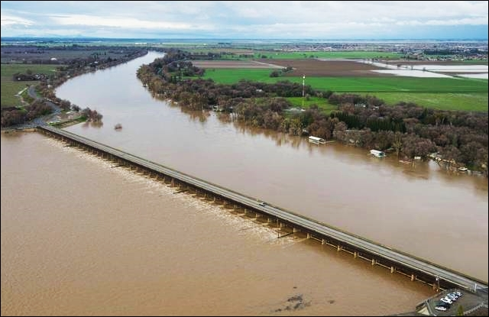
The Sacramento Weir Releasing Flood Waters Into The Yolo Bypass
(February 2017)

There are numerous potential benefits from such multiple points of entry, including the following:

(i) Greater Operational Flexibility - First, multiple points of entry located far apart from each other, allow for much greater operational flexibility regarding when, where and how water enters the Bypass at any given location. Such operational flexibility will provide important environmental benefits, such as providing more options for ongoing salmonid restoration efforts.

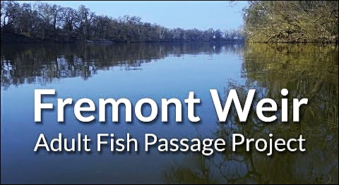

[Please see this 2019 Video about the Fremont Weir Adult Fish Passage Project]
https://www.youtube.com/watch?v=WtEpdaE8HMY&feature=youtu.be&t=54

(ii) Better Water Quality Assurances - Enhanced water quality assurances are yet another major benefit of these upstream entry points. Two of the three locations are situated well above the urban and industrial development in Sacramento. Thus, there is little or no chance of these water supplies becoming directly contaminated by toxic waste, untreated sewage, or other dangerous discharges cause by a catastrophic urban event downstream (e.g. an industrial plant explosion, an inoperable sewage system, etc.)

In addition, any adverse water quality impacts caused by poisonous discharges entering the Sacramento River below the upper two weirs, but above the third point of entry to the Bypass (e.g. the Deep Water Ship Channel), could be mitigated by simply closing-off the third entry point, thereby preventing the contaminated water from damaging the water quality of the other two fresh water sources.

Finally, even water contamination occurring below the third point of entry would not degrade the other two sources of clean water, because these other sources would no longer be forced to commingle with the degraded water at a single point of export, such as the DCP’s proposed tunnel near Hood.

(iii) Safer Spawning Locations for Delta Smelt - Third, all of these proposed points of entry are located far enough upstream to eliminate any possible danger to smelt attempting to spawn in the north delta, where the DCP now proposes to install three large water diversion intakes.
(b) A Natural Riverine Transport Corridor

Upon entering the Yolo Bypass, water will be transported south via a natural, surface-level riverine corridor, propelled by gravity. As proposed, the water passing downstream along this surface corridor would not be hidden in a deeply buried underground tunnel, nor would it be confined to a man-made concrete canal or engineered “straight jacket” of narrow levees. Rather, it would be allowed to carve out a natural meandering streambed all the way down to the point of export near Rio Vista. This has numerous benefits, including the following:

(i) Elimination of Virtually All Significant Adverse Impacts On The East-Side:

The DCP proposes to build an enormous 40 mile tunnel along the east-side of the Sacramento River. The significant adverse environmental, social and economic impacts of this project on the small delta communities and rich farmlands located near this east-side corridor are incalculable. Moreover it is virtually certain that many of these adverse impacts cannot be mitigated to the level of insignificance, as required by CEQA.

However, virtually all of these significant adverse impacts will be eliminated if the location of the water transport system is removed entirely from the east-side corridor and relocated to the west-side Yolo Bypass corridor instead.

(ii) The Potential for Significant Environmental Enhancements and Restoration:

Since the gold rush in 1849, California has lost more than 90% of its natural wetlands and native riparian habitat. The proposed alternative of a west-side surface river transport system through the Yolo Bypass will cause little, if any, additional harm to the natural environment. To the contrary, this natural riverine system will significantly aid in restoring much of the riparian habitat that existed in the floodplain before the Sacramento River was narrowly channelized in the late 19th century (to scour out hydraulic mine tailings.)

(iii) A Substantial Reduction in Total Project Costs and Construction Delays

By relocating the DCP from the east-side corridor to the west-side corridor, and by relying more on a gravity-driven surface transport system rather than a concrete tunnel from beginning to end, the total capital and operational costs of this project should drop substantially.

Why are these costs likely to drop? Here are four obvious reasons: (1) the capital costs of three large diversion intakes and related fish screens would be eliminated; (2) the capital costs of a much longer concrete tunnel will be reduced; (3) the operation and maintenance costs for a far smaller and simpler project will be lessened; (4) the extensive delays resulting from massive east-side community opposition and protracted litigation will be reduced; and (5) the probability of ultimately prevailing in the courts will be enhanced.

(c) Extraction Options At The Southern End of The Bypass

Water flowing down the Yolo Bypass is currently drained through a southern riparian channel known quite simply as the “Toe Drain.” This is one way to extract water from the Bypass for transfer to the export facilities near Tracy.

Another stationary export option might be a so-called “glory hole,” such as the one in operation at Lake Berryessa. Located near the Monticello dam, this spillway consists of a single, vertical, bell-shaped extraction portal that drops water 200 feet straight down, for release into Putah Creek at the base of the dam. The pipe has an intake diameter of 72 feet, which shrinks down to about 28 feet at its base. This spillway has a maximum capacity of 48,000 cfs, and operates whenever there is excess water in the reservoir. Below is a photo of the drain in operation following heavy rains that occurred in February 2017.

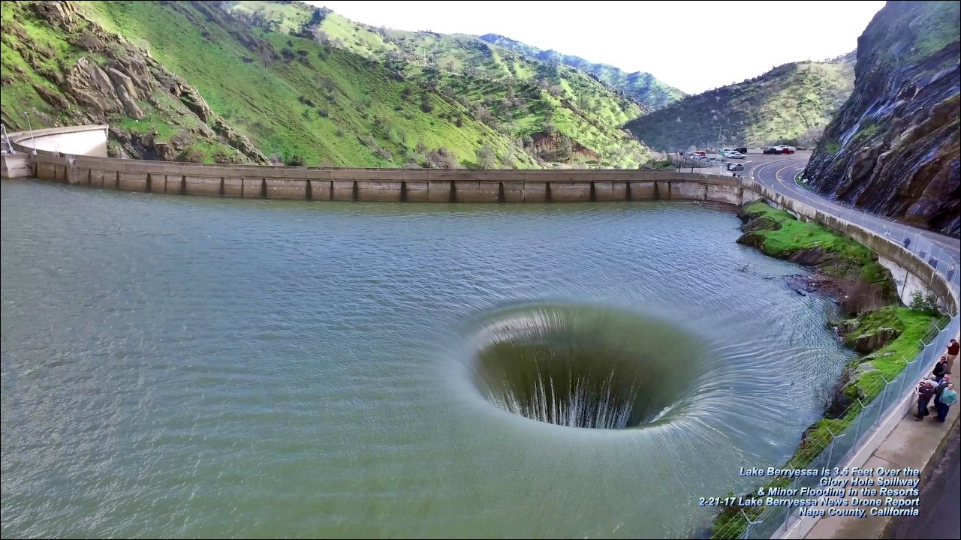
The “Glory Hole” at Lake Berryessa, February 2017

(i) Environmental Benefits: Removing fresh water supplies from the Bypass via this kind of gravity-driven downward draining device would eliminate the need for massive lateral drain intakes, which can cause extensive damage to aquatic eco-systems through entrainment and impingement of food-chain organisms and native fish.

(ii) Economic Benefits: The capital costs of three large lateral intakes would be eliminated, along with the operational and maintenance costs of such intakes. In addition, electricity could actually be generated at the export site, helping to offset any costs associated with pumping the water to its final destination, described below.

(d) A Transport System To Convey The Water to Export Facilities Near Tracy

The last leg of the journey is a transport system that can move water to the export facilities near Tracy. This transport process can be accomplished in several different ways, including pressurized pipes and/or a relatively short tunnel structure underneath the delta.

IV. Conclusion

Any effort to modernize the Delta water system, as directed in the Governor Newsom’s executive order, must include an honest and complete study of the west-side conveyance corridor. Consistent with the requirements of CEQA, I urge you to thoroughly evaluate the pros and cons of one or more west-side alternatives in both the draft and final environmental impact reports for the DCP. Thank you.

David F. Abelson

David F. Abelson, Environmental Law Attorney, Retired
Past Executive Director of the Planning & Conservation League

See Also:

1. Congressman John Garamendi’s West-Side Scoping Letters (dated 3-20-20 and 2-15-20): Attached.

2. Congressman John Garamendi’s Public DCP Scoping Statement (dated 3-20-20): Link
https://garamendi.house.gov/media/press-releases/garamendi-urges-california-consider-western-route-delta-conveyance

3. Rep. Garamendi’s West-Side Route Plan (“Water Plan for All of California,” pp.7-10, 2015): Link https://garamendi.house.gov/sites/garamendi.house.gov/files/Little%20Sip%20Version%208_compressed.pdf

